2.74: a) From Eq. (2.17), x(t) = αt –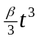 = (4.00 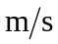)t – (0.667 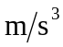)t³. From Eq. (2.5), the acceleration is a(t) = –2βt = (– 4.00 )t.
b) The velocity is zero at 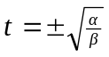 (a = 0 at t = 0, but this is an inflection point, not an extreme). The extreme values of x are then

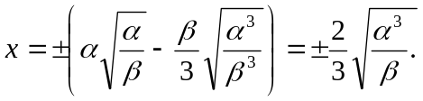
The positive value is then
